**INFM 600 – PBJ Documentation**

**Task**

Technical writing for step-by-step process documentation on how to make a quintessentially American delicacy: Peanut Butter and Jelly (or jam) Sandwich.

**About PBJ Sandwich**

The creation of Peanut Butter and Jelly Sandwiches was a pivotal point in the attempts to fine tune nature and man’s relationship to one. The combination of thick yet creamy Peanut Butter, alongside its trusted lover Jelly together provide the loving relationship people aspire for and more often then not is only attainable through literature. That with the support of a strong yet doughy home we call “bread” incasing the two is natures blessing to us rightfully undeserved but damn near perfection.

**History of PBJ Sandwich**

The now immortal peanut butter and jelly sandwich was first located and published by Julia Davis Chandler in 1901. This food invention became popular among America's youth, who loved the double-sweet combination, and it has remained a favorite ever since. During the early 1900s peanut butter was considered a delicacy and as such it was served at upscale affairs and in New York's finest tearooms.

Source: Peanuts: The Illustrious History of the Goober Pea, Andrew F. Smith. University of Illinois Press, Urbana. 2002.

**5 Reasons people love PBJ Sandwich**

* It’s comforting
* It’s delicious
* It’s power packed
* It’s versatile and convenient
* It’s fast and affordable

Source: <http://www.nationalpeanutboard.org/news/5-reasons-pbj-is-best-sandwich-ever.htm>.

**How does a PBJ Sandwich look**

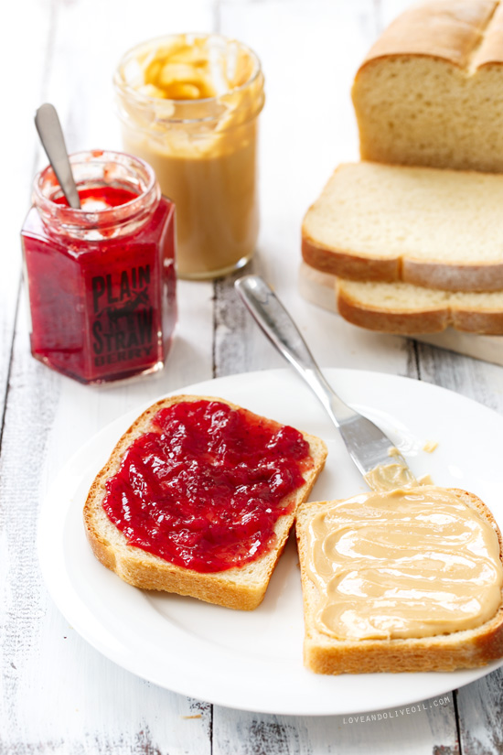

Image Source: https://www.loveandoliveoil.com/2014/10/ultimate-scratch-made-peanut-butter-and-jelly-sandwiches.html.

**Ingredients Required**

1. Bread
2. Peanut Butter
3. Jelly
4. Butter knife and Cutting Knife
5. Plate
6. Disposable Gloves
7. Tablespoon
8. Tissues and Cleaning Cloth

All the aforementioned requirements are easily accessible through nearby grocery stores, departmental stores and shopping centers. It is highly recommended to review the manufacture and expiration days of edible items from the requirements for better quality of the consumables.

**Skills Required**

* Counting two objects
* Knowledge of “side-be-side”
* Good hand-eye co-ordination
* Untwisting and opening Jars
* Holding and using a knife
* Knowledge of Tbsp measures
* Knowledge of applying spreads
* Knowledge of cutting crusts of breads

**Steps to Make a Peanut Butter & Jelly Sandwich (PBJ Sandwich)**

1. **Setting the environment ready**
   * Clean the table you will be using to make the sandwich.
   * Wash the plate, knives, and spoons to be used.
   * Wear the disposable gloves.
   * Bring all ingredients on the table.
2. **Preparing the ingredients** 
   * Place the plate in center of the table.
   * Open the bread packed and pick out two similar sized slices of bread & place them on the plate.
   * Open the peanut better box cap and unseal the box.
   * Open the Jelly Jar and unseal the jar.
3. **Making the PBJ Sandwich**
4. **STEP 1**
   * Scoop out peanut better using the better knife, about 2 Tbsp.
   * Hold one slice of bread in one hand.
   * Apply the scooped peanut butter over the slice and spread out evenly.
   * If the bread slice has empty gaps, fill it with more peanut butter.
   * Put the bread slice back on the plate.
   * Wash the knife and dry it using cleaning cloth.
5. **STEP 2**

* Scoop out Jelly from the Jelly Jar using the butter knife, about 2 Tbsp.
* Hold another slice of bread in one hand.
* Similarly, as for peanut butter, apply the jelly over the bread slice and spread evenly.
* If there are empty gaps in the bread slices, apply some more jelly to fill them.
* Put the bread slice back on the plate.
* Wash the knife and dry it using cleaning cloth.

1. **STEP 3**

* Pick both the slices of applied jelly and peanut butter in both hands.
* Place one slice over the another gently and proportionally with both the spread facing each other.
* Confirm if the sides are stacked properly with one exactly on top of another.
* Place the sandwiched breads back on the plate.

1. **STEP 4**

* Take the cutting knife and gently remove the crusts of the sandwich without wasting the inner portion of the sandwich.
* Wash the cutting knife and dry using cleaning cloth.

1. **Serving** 
   * Serve the Peanut Butter & Jelly Sandwich in a fresh plate.
   * Serve the PBJ Sandwich preparation with some exotic sauces, herbs and wafers. (optional)

**Flow Diagram for making a PBJ Sandwich**

GATHER ALL INGREDIENTS

PREPARE THE ENVIRONMENT

TAKE 2 SLICES OF BREAD

APPLY/SPREAD 2TBSP OF JELLY ON ONE BREAD SLICE

APPLY/SPREAD 2TBSP OF PEANUT BUTTER ON ONE BREAD SLICE

NO NO

SPREAD APPLIED PROPERLY?

YES

SERVE THE PBJ SANDWICH

STACK BOTH SLICES FACING EACH OTHER AND CUT THE CRUSTS